|  |  |
| --- | --- |
| ***Reference:*** *OPA/2018/WEB-001* | 28 February 2018 |

Dear Reader,

Thank you for downloading the New York 501(c)(3) Not-for-Profit Corporation Certificate of Incorporation Form from our firm’s website, www.jameshsuilaw.com.

While this form has been prepared by us, gratis, for your convenience, it is ***provided to you for general informational purposes only***. It is ***not legal advice, and should not be used as a substitute for legal or other advice***.

Please be aware that ***your use of this form does not create a client-attorney relationship between you and us***. We ask all our clients to sign letters of engagement with us, in accordance with New York’s rules governing attorneys. These letters confirm the relationship between us and our clients, and describe the specific parameters of the unique relationship with each distinct client. ***Unless you have signed such a letter, we are not your lawyer***. If you have signed such a letter with our firm, please let us take this opportunity to thank you for choosing us!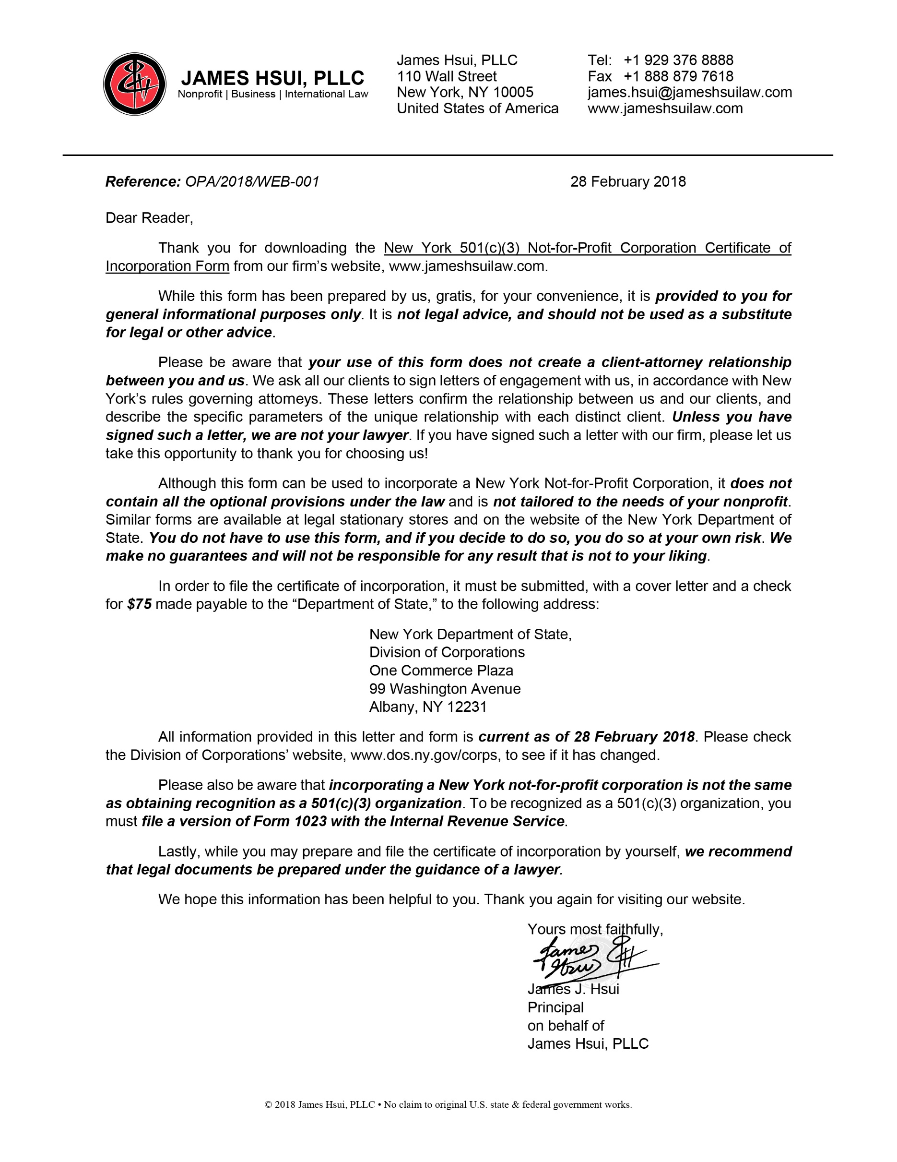

Although this form can be used to incorporate a New York Not-for-Profit Corporation, it ***does not contain all the optional provisions under the law*** and is ***not tailored to the needs of your nonprofit***. Similar forms are available at legal stationary stores and on the website of the New York Department of State. ***You do not have to use this form, and if you decide to do so, you do so at your own risk***. ***We make no guarantees and will not be responsible for any result that is not to your liking***.

In order to file the certificate of incorporation, it must be submitted, with a cover letter and a check for ***$75*** made payable to the “Department of State,” to the following address:

New York Department of State,   
Division of Corporations  
One Commerce Plaza  
99 Washington Avenue  
Albany, NY 12231

All information provided in this letter and form is ***current as of 28 February 2018***. Please check the Division of Corporations’ website, www.dos.ny.gov/corps, to see if it has changed.

Please also be aware that ***incorporating a New York not-for-profit corporation is not the same as obtaining recognition as a 501(c)(3) organization***. To be recognized as a 501(c)(3) organization, you must ***file a version of Form 1023 with the Internal Revenue Service***.

Lastly, while you may prepare and file the certificate of incorporation by yourself, ***we recommend that legal documents be prepared under the guidance of a lawyer****.*

We hope this information has been helpful to you. Thank you again for visiting our website.

CERTIFICATE OF INCORPORATION  
OF

[NAME OF CORPORATION]

Under Section 402 of the Not-for-Profit Corporation Law of the State of New York

**FIRST:** The name of the corporation is:

[Name of Corporation] (the “Corporation”).

**SECOND:** The Corporation is a corporation as defined in subparagraph (5) of paragraph (a) of Section 102 of the Not-for-Profit Corporation Law (the “N-PCL”).

**THIRD:** Subject to any limitations and restrictions in this certificate of incorporation (the “Certificate”) and the bylaws of the Corporation, the purpose for which the Corporation is formed is:

any purpose for which corporations may be organized under the N-PCL as a charitable corporation.

**FOURTH:** The Corporation is not formed to engage in any act or activity described in Section 404 of the N-PCL, in the State of New York, requiring any consent or approval of any state official, department, board, agency or other body of the State of New York. No such consent or approval is required.

**FIFTH:** The Corporation is a: charitable corporation under Section 201 of the N-PCL.

**SIXTH:** The office of the Corporation is to be located in the County of [County], in the State of New York.

**SEVENTH:** The names and addresses of the initial directors of the Corporation are:

[Name and Address of a Minimum of Three Directors   
(Use as Many Lines as Necessary)]

**EIGHTH:** The Secretary of State is designated as agent of the Corporation upon whom process against it may be served. The address to which the Secretary of State shall mail a copy of any process accepted on behalf of the Corporation is:

[Name and Address   
(Use as Many Lines as Necessary. Documents Related to Lawsuits against the Nonprofit are Sent to this Address)]

**NINTH:** The Corporation shall be a corporation exempt from federal income tax under Section 501(c)(3) of the Internal Revenue Code of 1986 (the “Code”). Any reference contained in this Certificate to a specific section of the Code shall be deemed to refer to such section as it now exists or as it may hereafter be amended, and to any corresponding provision of any future United States tax code.

**TENTH:** Notwithstanding any other provision in this Certificate, the Corporation is organized, and shall be operated, exclusively for one or more of the purposes described in Section 501(c)(3) of the Code; and shall not carry on any act or activity not permitted to be carried on by an organization exempt from federal income tax under Section 501(c)(3) of the Code, or by an organization, contributions to which are deductible under Section 170(c)(2) of the Code.

**ELEVENTH:** No substantial part of the activities of the Corporation shall be devoted to carrying on of propaganda, or otherwise attempting to influence legislation, except to the extent permitted by Section 501(h) of the Code, and no part of the activities of the Corporation shall be devoted to participating in, or intervening in (including the publishing or distribution of statements), any political campaign on behalf of or in opposition to any candidate for public office.

**TWELFTH:** No part of the net earnings of the Corporation shall inure to the benefit of, or be distributable to, its members, trustees, directors, officers, or other private persons, except that the Corporation shall be authorized and empowered to pay reasonable compensation for services rendered, and to make payments and distributions, in furtherance of one or more of the purposes described in Section 501(c)(3) of the Code.

**THIRTEENTH:** In any taxable year in which the Corporation is a “private foundation” within the meaning of Section 509 of the Code, the Corporation shall distribute its income for that taxable year at such time and in such manner so as not to subject the Corporation to tax under Section 4942 of the Code, and shall not: engage in any act of self-dealing which is subject to tax under Section 4941 of the Code; retain any excess business holdings which are subject to tax under Section 4943 of the Code; make any investments in such manner as to subject it to tax under Section 4944 of the Code; or make any taxable expenditures which are subject to tax under Section 4945 of the Code.

**FOURTEENTH:** Upon the dissolution of the Corporation, the assets of the Corporation shall, except as may otherwise be provided or required by applicable law, be distributed for one or more exempt purposes within the meaning of section 501(c)(3) of the Code, or be distributed for a public purpose to federal, state or local government. Such distribution of assets shall be made in such manner as the board of directors may determine, in its discretion, subject to the approval of the Attorney General, or a Justice of the Supreme Court, of the State of New York, to the extent such approval is required by the N-PCL. In the event there are no directors and there are remaining assets of the Corporation, such distribution of assets shall be made in such manner as a court of competent jurisdiction of the county in which the principal office of the corporation is then located may determine.

**FIFTEENTH:** The existence of the Corporation shall be perpetual.

__________________________

[Name of Incorporator]

Incorporator

[Address of Incorporator]

CERTIFICATE OF INCORPORATION  
OF

[NAME OF CORPORATION]

Under Section 402 of the Not-for-Profit Corporation Law of the State of New York

**FILED BY:** [Name of Incorporator]  
[Address of Incorporator]